**Master Functional Document**

|  |  |
| --- | --- |
| **Application** | NGERP - Centra |
| **Service Bundle** | Master Management |
| **Service Request** | Lot |

**Description :**

Lot Master is used to view the created lots in material receipt. User can able to view the created and expiry date for the lot in Attribute Set Instance Master.

**Workflow Process :**

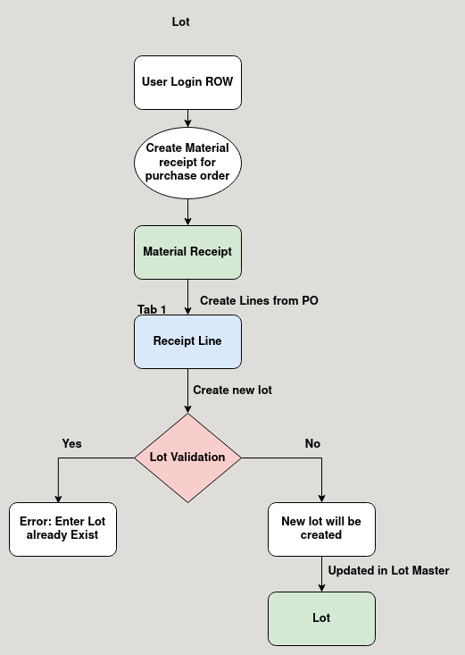

**Business Rules :**

* User Login Region to create lot in material receipt.
* Lot is a storage area inside locator to store products.
* User can create new lot or choose existing one to store the purchased product.
* Every lot name should be unique.
* User cannot create a new lot if there is already an existing one.
* The expirey date of the lot should be given when creating a new lot.
* The expiry date of the product is the expiry date of the lot.